Commodore PET/CBM80xx/40xx Diagnostic Clip **Rev. 2**

**Testing**

# Test Setup

The tests were conducted with the following setup:

* Diagnostic Clip Rev. 2
* 6502 Ribbon Cable Adapter Rev. 1
* Ribbon Cable (10 cm and 15 cm)
* User Port Dongle Rev. 0
* Keyboard Dongle Rev. 0
* Commodore CBM8032
* Commodore CBM3016

The CBM8032 was tested with the software “80_col_diagnostic_v1.1.bin”

The CBM3016 was tested with the software “901447-30_diagnostic_320350g_$9000.bin”

The software “40_col_diagnostic_v2.0.bin” was partly tested with the CBM3016 and with the CBM8032.

The 6502 was inserted into the ribbon cable adapter, which then was installed in the CPU socket of the respective computer. The ribbon cable was connected to the ribbon cable adapter.

Later, the diagnostic box was connected to the ribbon cable, the keyboard and the user port dongle were connected to the respective connector of the main board. The IEEE-488 interface was open, the cassette port was not connected to a Datassette.

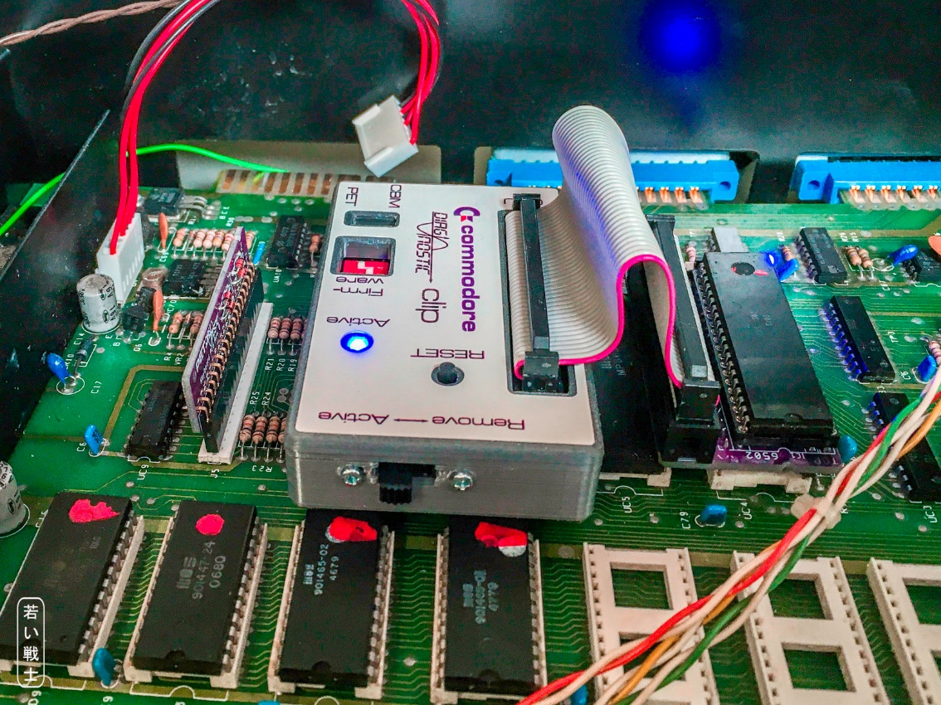

Figure 1: Testing the Diagnostic Clip in the CBM 3016

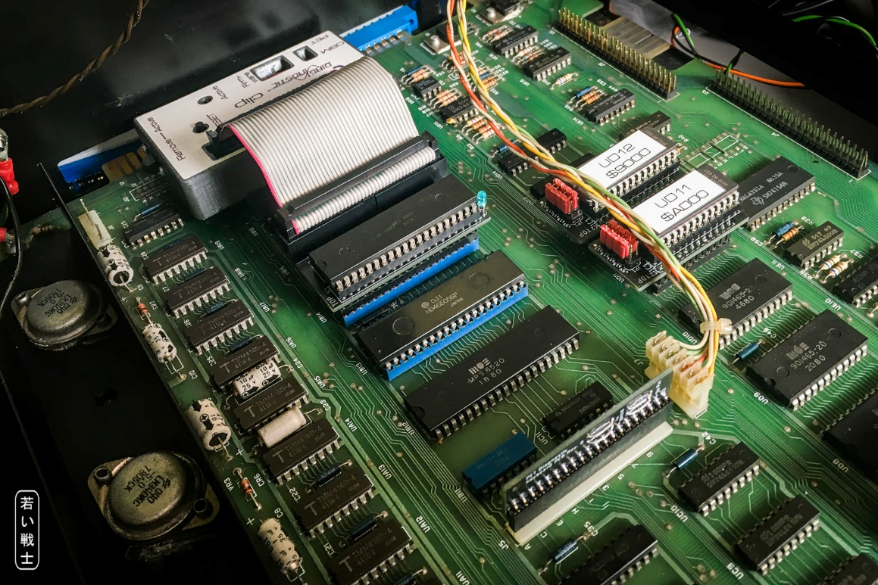

Figure 2: Test in CBM8032

# Test Execution

## Interference Test

First, the computer was started with the ribbon cable adapter with the ribbon cable only. The computer was operated over an hour. No crash was experienced. Next, the diagnostic box was connected to the said setup. The computer was used for several hours. No interference was found. **The computer operated properly**.

## Diagnostic Test

The User Port and Keyboard Dongles were connected. The Diagnostic Clip was switched to “active”. The computer was switched on.

* The first page of the diagnostic was shown. All tests were performed properly (refer to module description)
* The switch was then toggled to “remove”.
* The actual diagnostic tests were repeatedly performed without error messages until the computer was switched off (refer to module description).

# Test Result

**The Diagnostic Clip, the adapter and the dongles are working properly.**